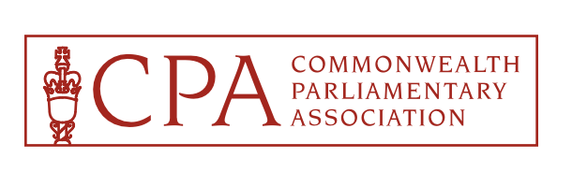


1st Joint CPA Asia & South-East Asia Regional Conference
Lahore, Punjab, Pakistan
6th to 10th February 2025

BIOGRAPHICAL DETAILS

Please complete and return this form to Ch. Amer Habib, CPA Punjab, Branch Secretary, either by Email: cpapunjab2025@gmail.com, legislation.branch@pap.gov.pk or by Fax: +92 – 42 – 99200330 or by WhatsApp: +92 – 321 – 7450085

IMPORTANT

To be completed and returned to the CPA Punjab Branch with two identifiable passport size photographs by: 15th December 2024

Completion of this Form will indicate that you agree to the publishing of the information provided in the Biographies’ Booklet, to be provided to all participants. You may wish to complete only the sections you consider necessary. Please note that there is a limit of 250 words for each section.

FULL NAME: (block letters please)
UNDERLINE your surname, and include title (e.g. Hon., Dr., Mr., Ms., Mrs.) decorations (if any) and parliamentary abbreviation after name e.g. MP, MNA

CPA BRANCH: OFFICE HELD IN CPA BRANCH – if any
(e.g. President, Member or Executive Committee)

PHOTOS:
Two identified passport sized photos of me (and my spouse, if accompanying):

Are enclosed

Will be sent by……

(Photos will be used for your ID card and the biographies booklet)

DATE OF BIRTH: GENDER:

Male
(Day………..Month…………Year………..….)
Female

…

YEAR FIRST ELECTED TO PARLIAMENT:

POLITICAL PARTY (Please give full name):

PRESENT PORTFOLIO / OFFICE (If any e.g. Minister of Foreign Affairs, Leader of Opposition):

EDUCATION:

INTERESTS / RECREATIONS:

CAREER: (in outline only)

PREVIOUS CPA CONFERENCES, SEMINARS, VISITS, WORKSHOPS ATTENDED:

NAME BADGES:
Please indicate here how you wish your name to be printed on your name badge

SPOUSE’S NAME BADGE:

Are you accompanied by a spouse? Name of spouse to appear on name badge:
Yes No

