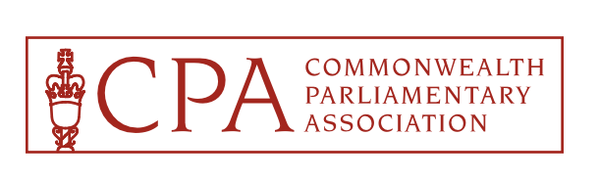


1st Joint CPA Asia & South-East Asia Regional Conference
Lahore, Punjab, Pakistan
6th to 10th February 2025

ACCEPTANCE FORM

Please complete and return this form to Ch. Amer Habib, CPA Punjab, Branch Secretary, either by Email: cpapunjab2025@gmail.com, legislation.branch@pap.gov.pk or by Fax: +92 – 42 – 99200330 or by WhatsApp: +92 – 321 – 7450085

IMPORTANT

To be completed and returned to the CPA Punjab Branch by: 15th December 2024

We will be attending the 1st Joint CPA Asia & South-East Asia Regional Conference, to be held in Lahore, Punjab, Pakistan, from 6th to 10th February 2025. [ Yes / No ]

Branch: …………………………………………….…………………………………………………………

Date: …………………………………………….…………………………………………………………

Contact name: …………………………………………….…………………………………………………………
(Branch Secretary)

Telephone number: …………………………………………….…………………………………………………………
(including areas and city codes)

Fax number: …………………………………………….…………………………………………………………

WhatsApp number: …………………………………………….…………………………………………………………

Email: …………………………………………….…………………………………………………………

